**PHASE 3: MACHINE LEARNING MODEL DEPLOYMENT USING IBM CLOUD WATSON STUDIO**

**INTRODUCTION:**

In this phase 3 submission file we are going to see about what kind of tools are used to build an machine learning model using ibm cloud watson studio.

**LOGGING IN CLOUD:**

At first we have logged in to the cloud account using the feature code in skillup.online . It is an trial version of the IBM cloud in which we can use it with some restriction.

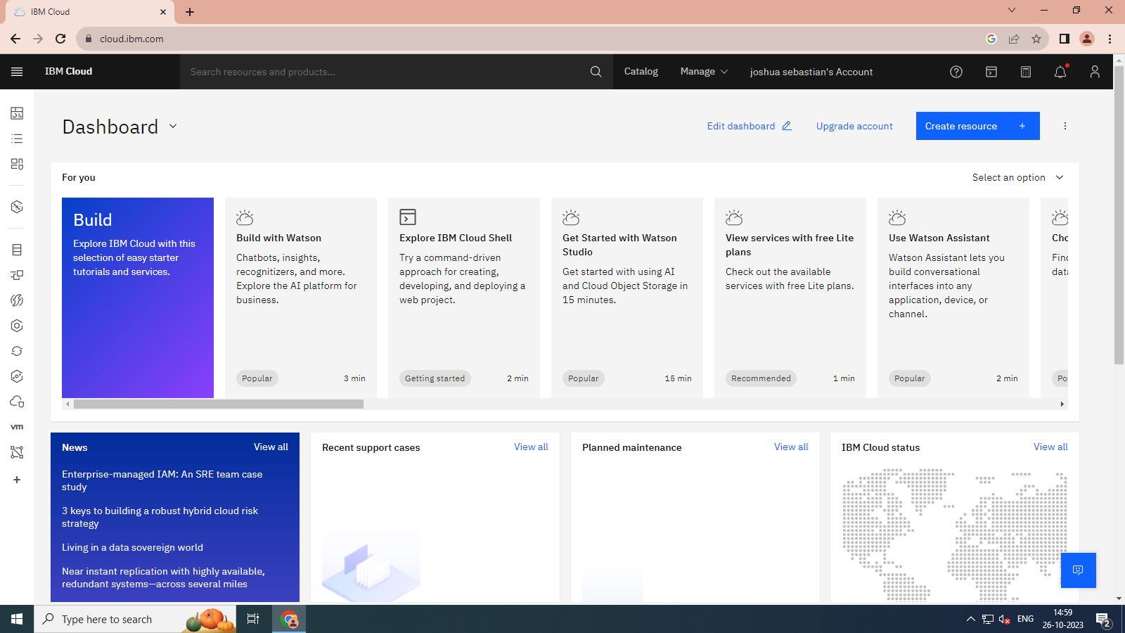

**DATABASE STORAGE:**

After we logged into the cloud we must create the database for storing the machine learning model in the ibm cloud data base system. Here we are using the DB2 database storage space to store our machine learning model. Now the database Db2 had been created.

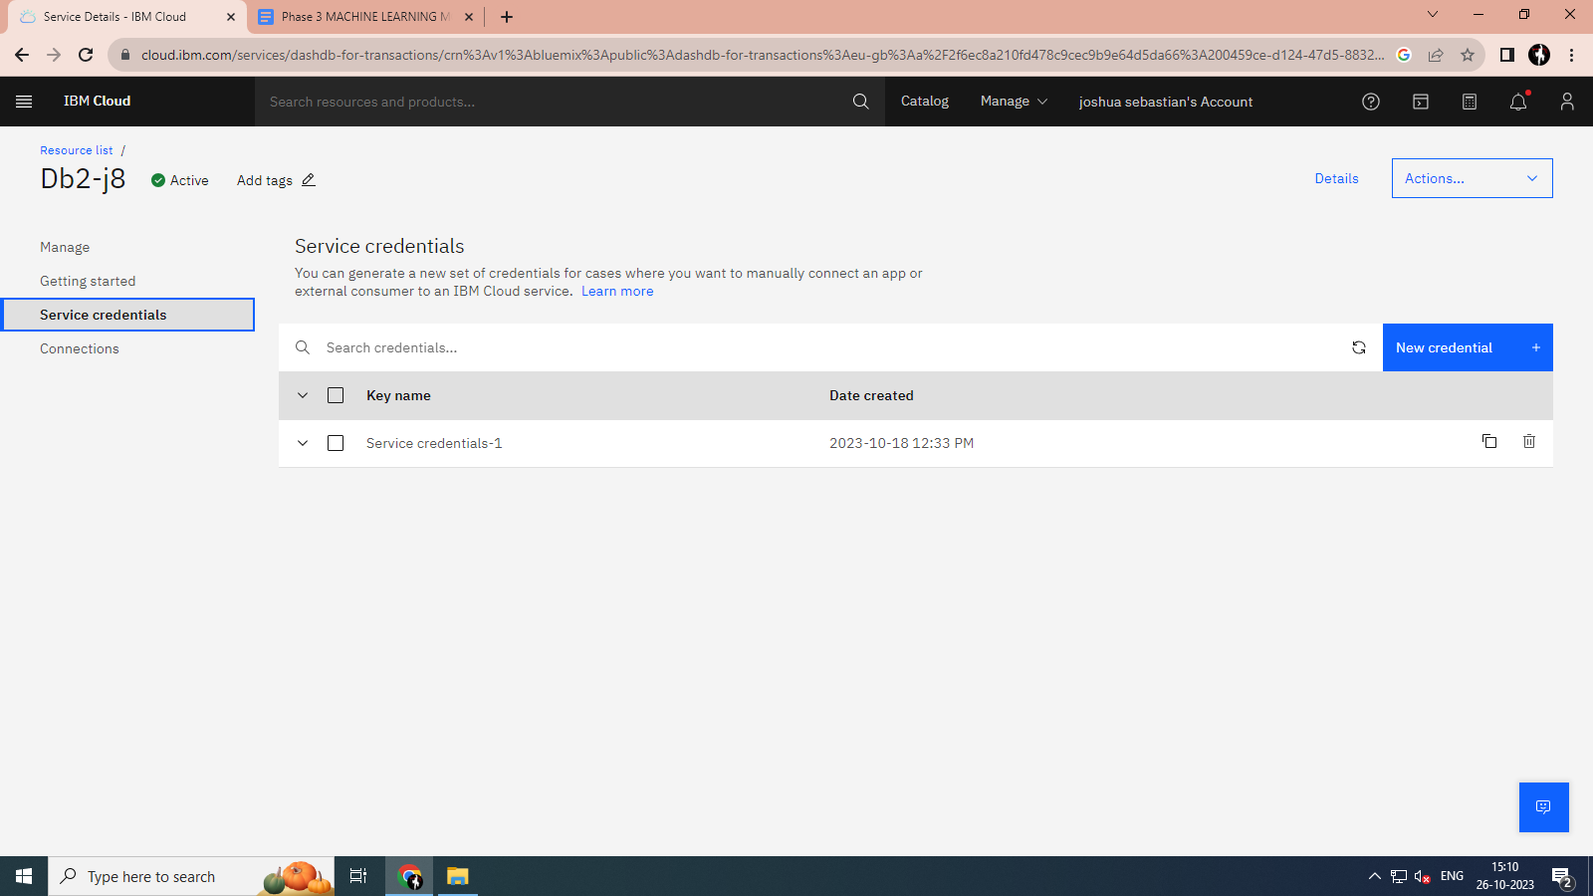

**CLOUD OBJECT STORAGE:**

After we created the database for storing the machine learning model now we can create the cloud object storage space. And we should create the credential for the cloud object storage area and take the key, paste it on watson machine learning code.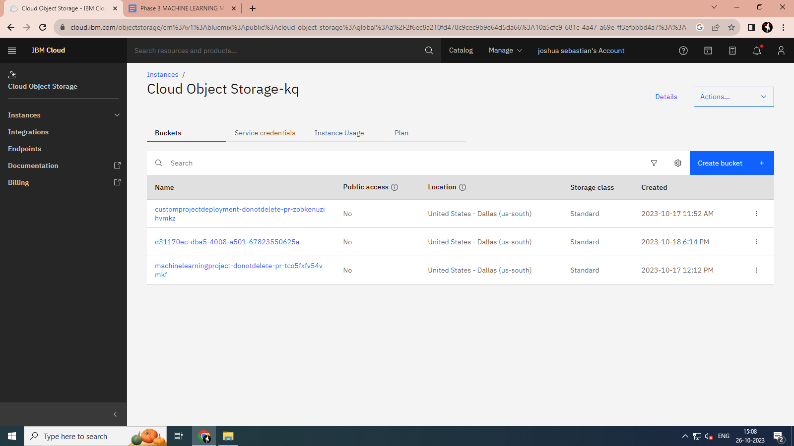

**CONCLUSION:**

In the phase 3, we saw that tools and the requirement which are going to use in the machine learning model. In the next phase of phase 4, we can see in detail about the development of the project and the code.

**WATSON MACHINE LEARNING:**

This the watson machine learning interface in which the machine learning algorithm going to be work. Using these machine learning model of watson studio we can create the machine learning model.

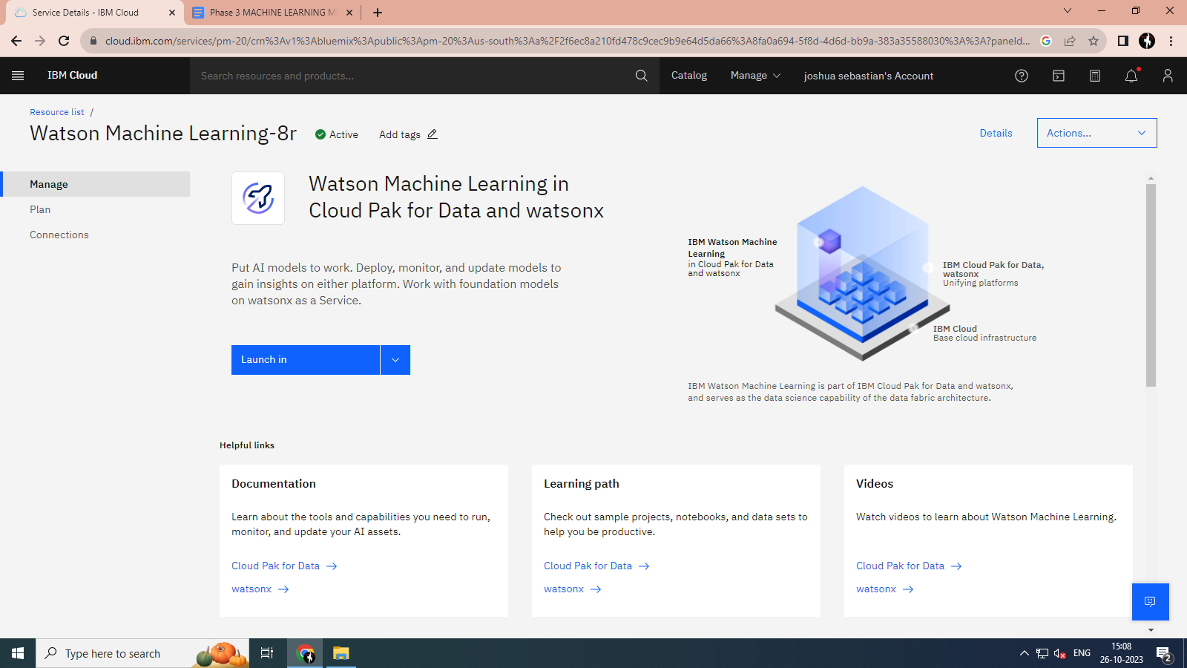

**WATSON STUDIO:**

Using the watson studio we can build an machine learning model and can work with the model to bring the desired output from the machine learning model.

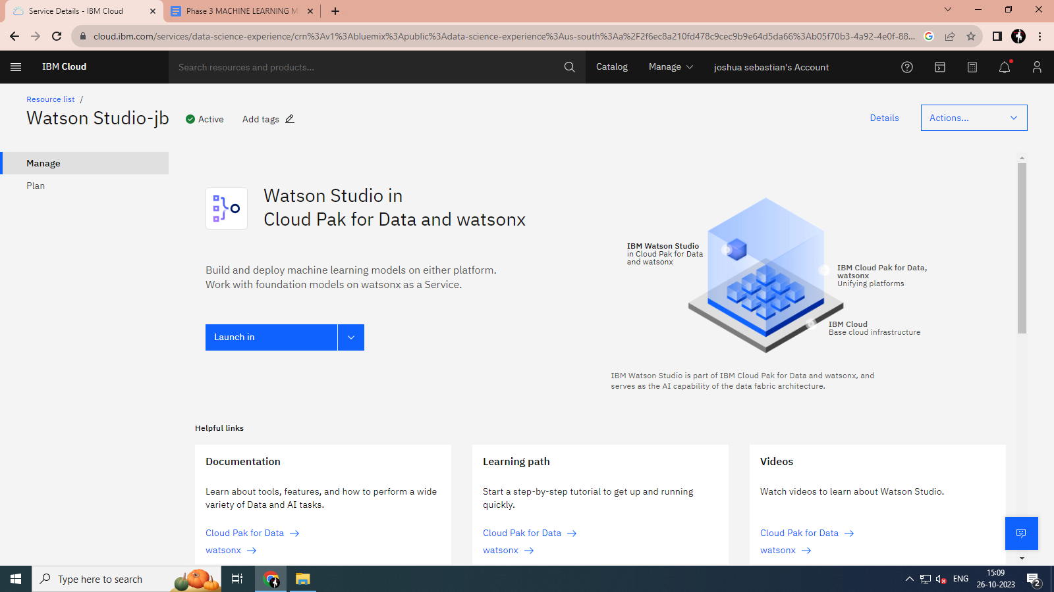

**DATA PAK OF IBM CLOUD:**

The data pak of ibm cloud is the interface in which the development of the machine learning model can be done. And also the deployment of the project should be done here. Using the data pak of ibm cloud we can create the sample or an empty project to work with it.

